* checked exception me autoducking nahi hoti hai lekin hum Throws keyword se throw kar sakte hai exception unchecked exception me autoducking / automatic mebhi aisa hi kuch hota hai internaly
* unchecked exception me autoducking automatic hoti hai

#Throws

* It is required only for checked exception and for unchecked exception there is no use

***Deffi*** *.* we can use to delegate responsibility of exception handling to the caller (jvm or onother methods)

# Exception propagation

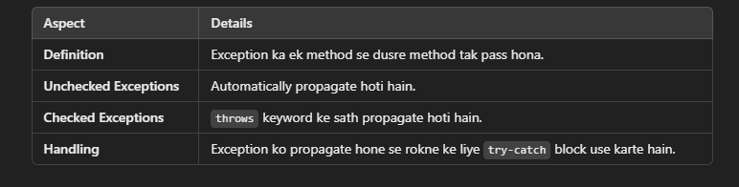

# Re Throwing Exception

* Manlo 10/0 ab arithemethic exception aayegi or use apn ne try-catch block se handel kar liya hai or catch ke andar apn throw keyword se apn nullpointer exeption generate kar raha hai matlab ek exception ko dusri exeption me convert kar rahe hai
* 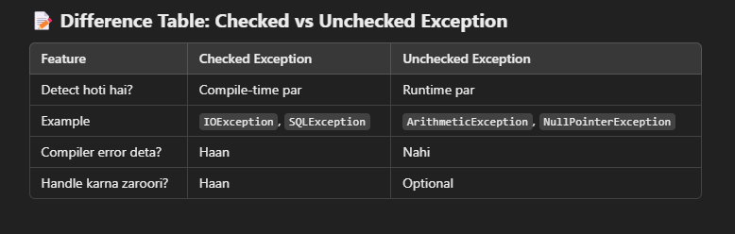**Checked Exception**: Compiler ko pata hoti hai, handle karna zaroori hai.
* **Unchecked Exception**: Runtime par aati hai, handle karna zaroori nahi hai